

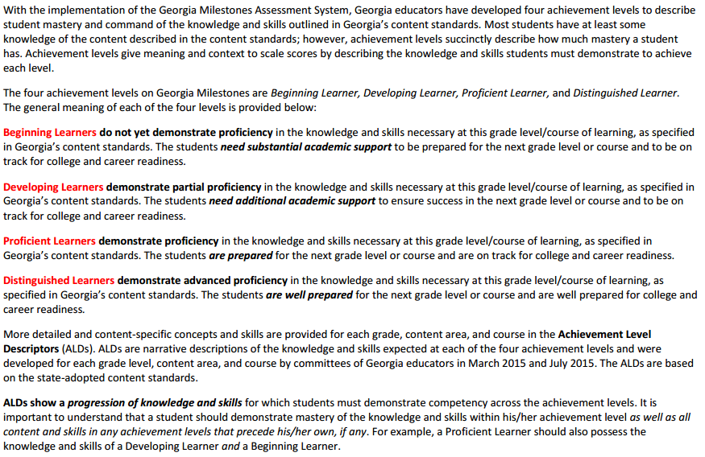

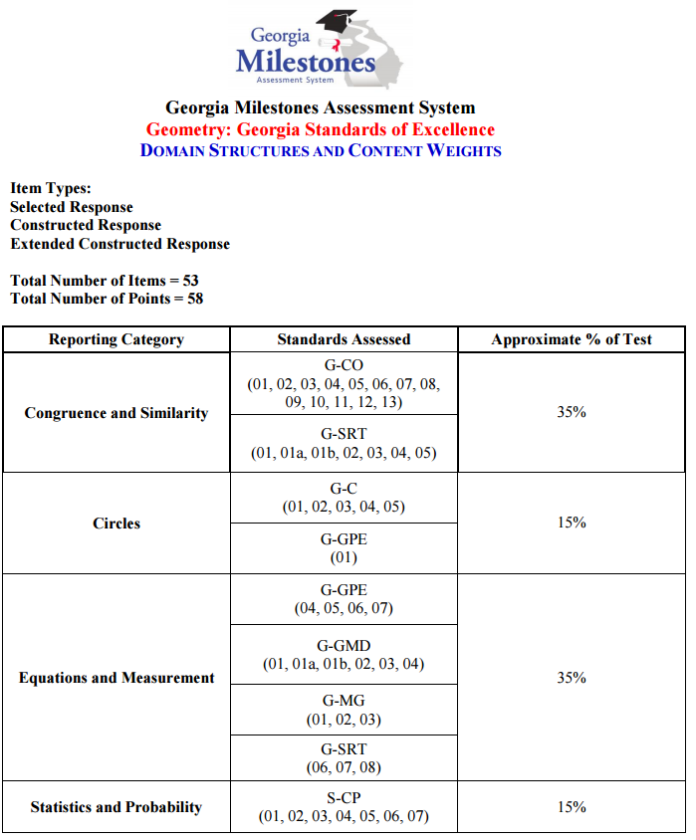

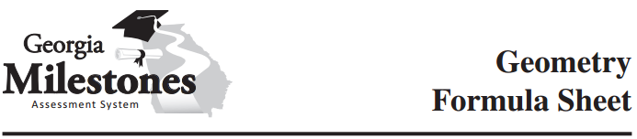

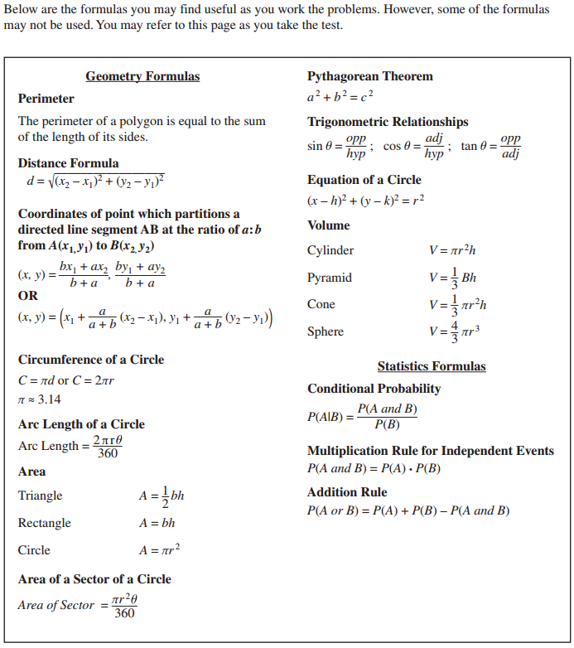

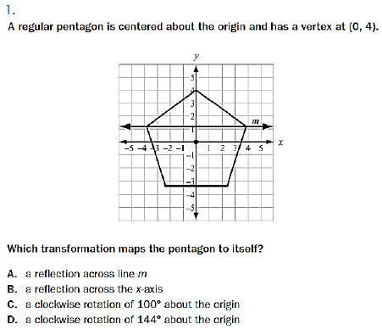**EOCT Review: Transformations # 1 – 6**

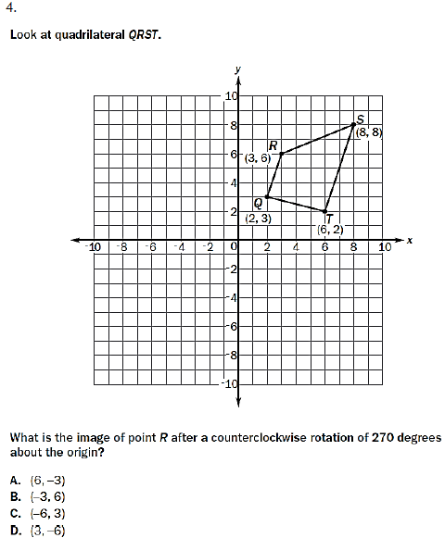

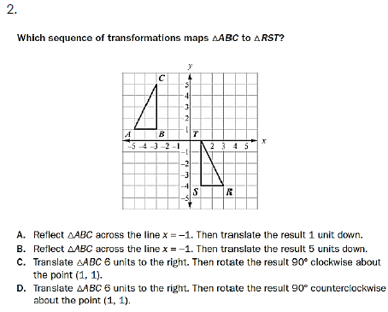

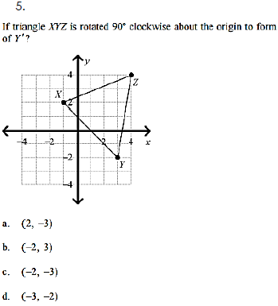



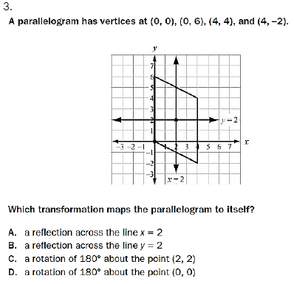

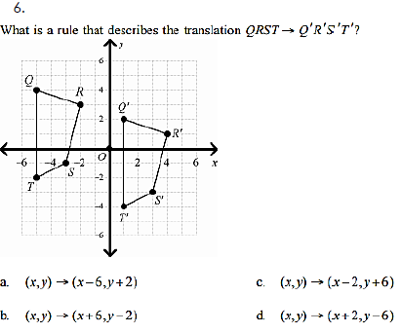

**EOCT Review: Coordinate Geometry # 7 – 13**

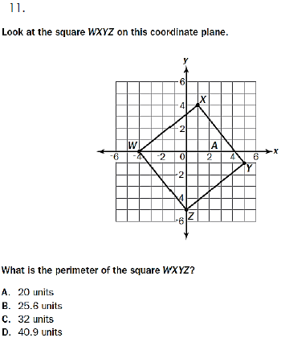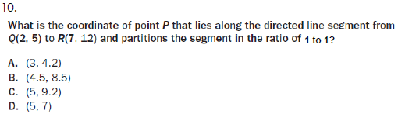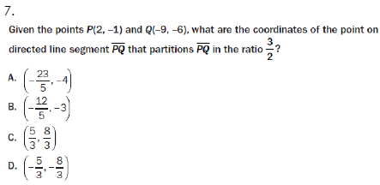

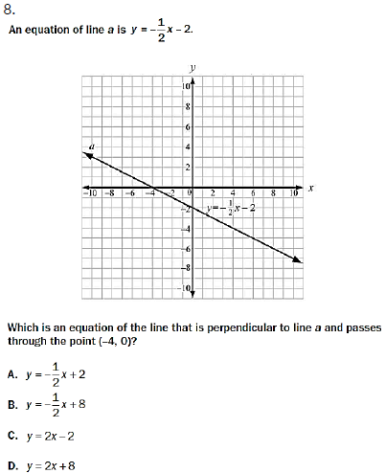

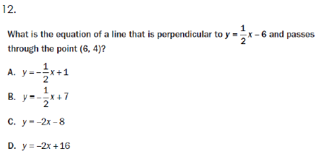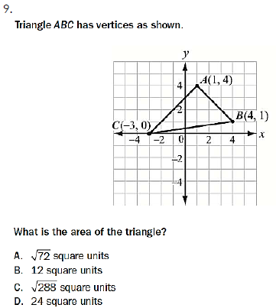

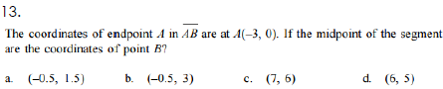



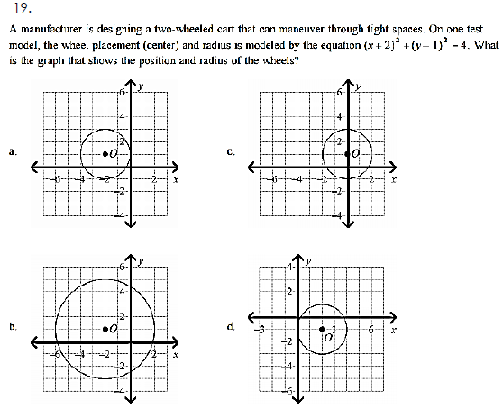**EOCT Review: Equations of Circles # 14 – 22**

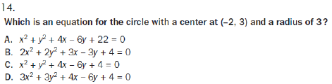

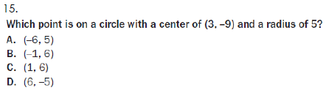

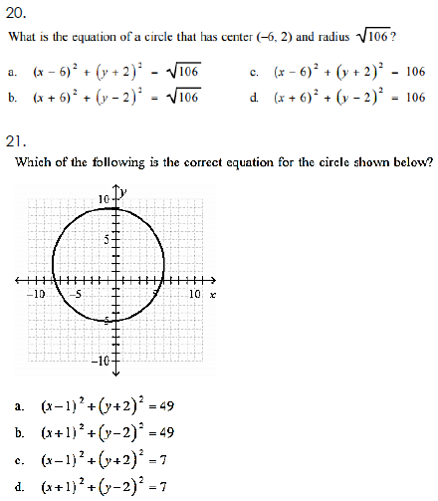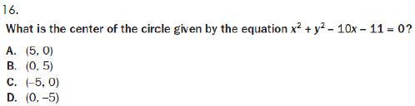

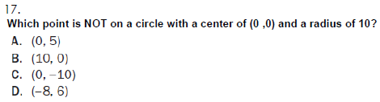

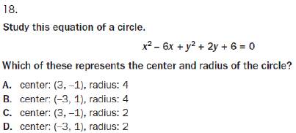

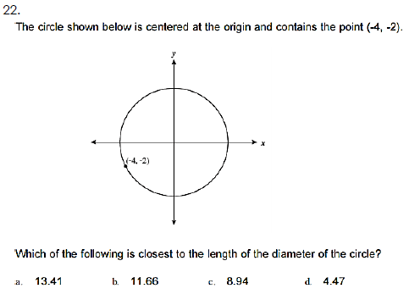

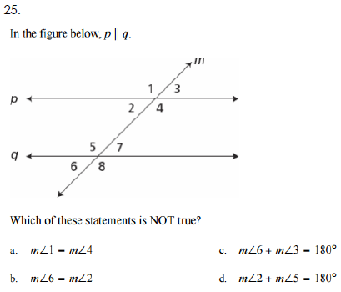**EOCT Review: Basics of Geometry # 23 – 26**

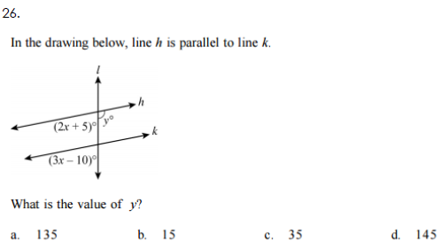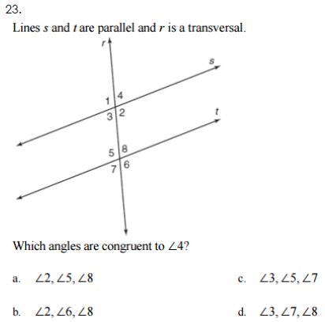

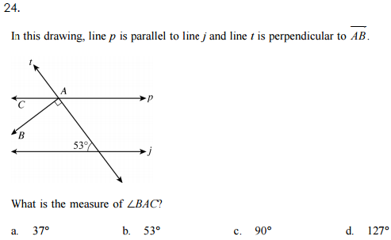

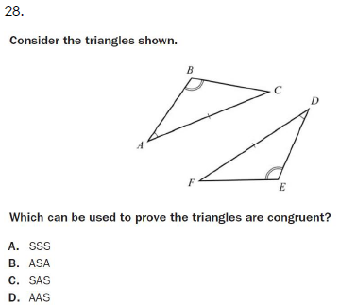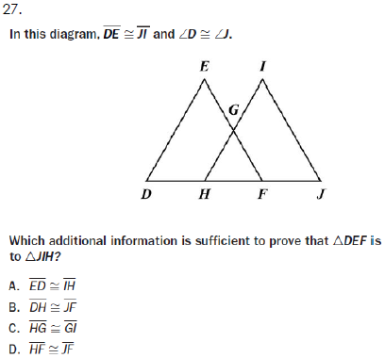**EOCT Review: Triangles # 27 – 35**





**EOCT Review: Triangles # 27 – 35 (Continued…)**

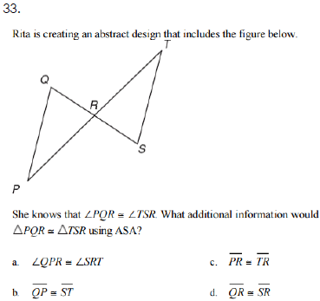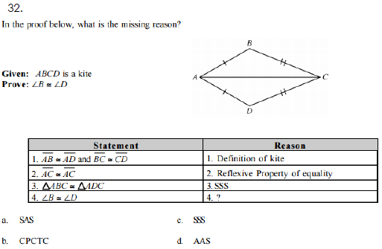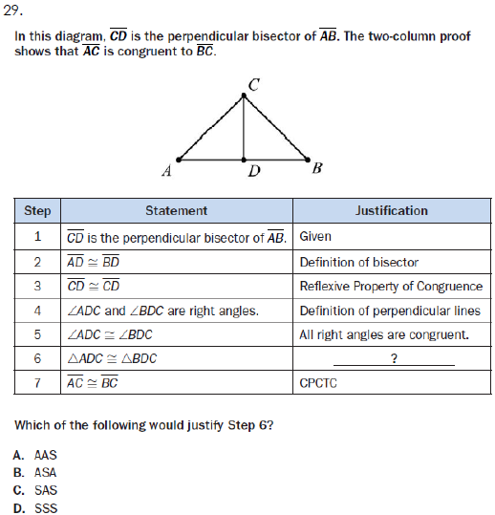

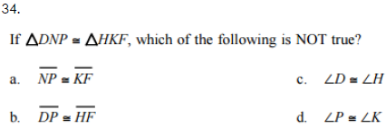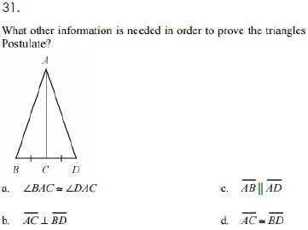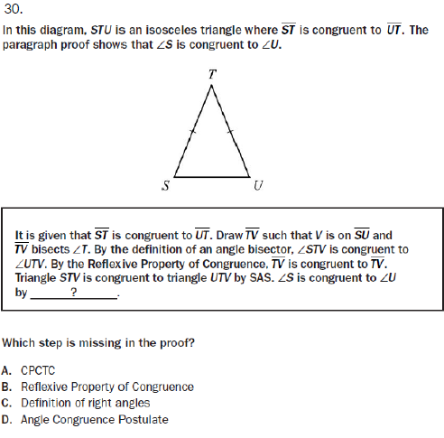

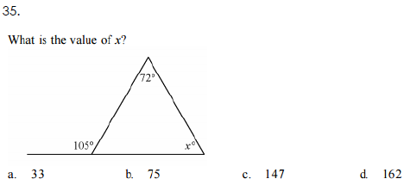

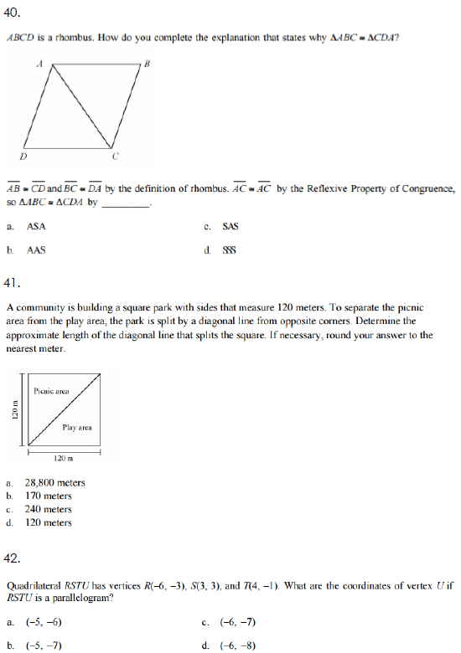**EOCT Review: Quadrilaterals # 36 – 43**

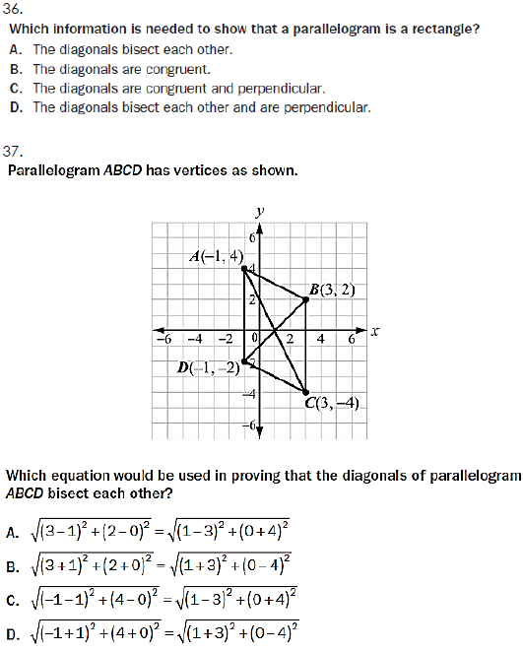

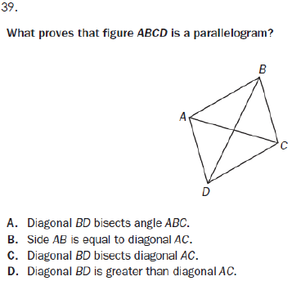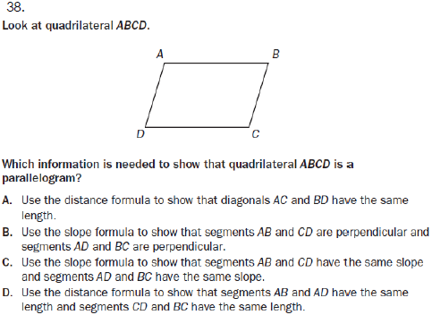

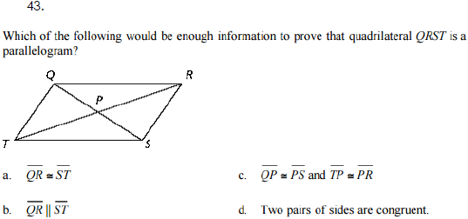

**EOCT Review: Right Triangle Trigonometry # 44 – 51**

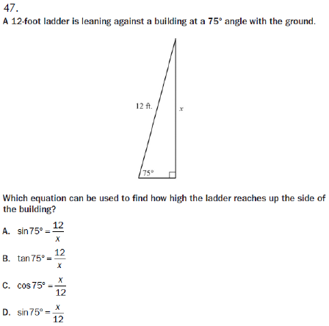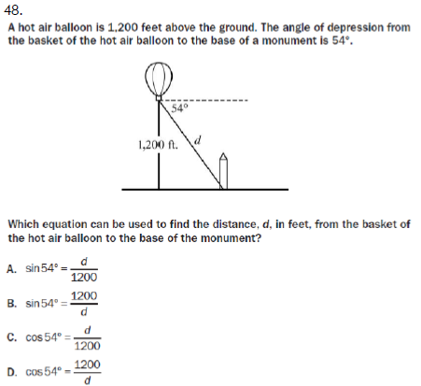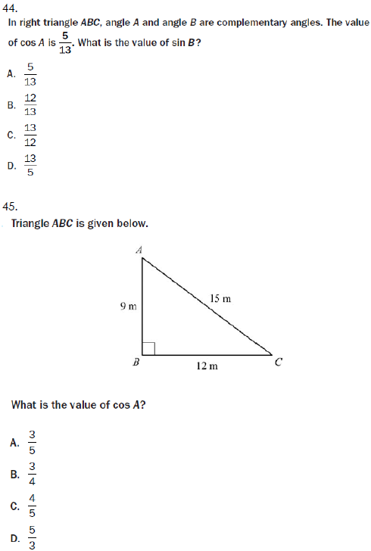

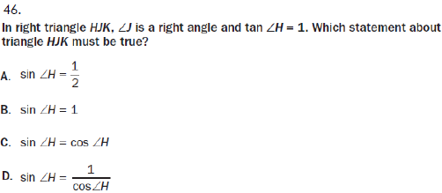

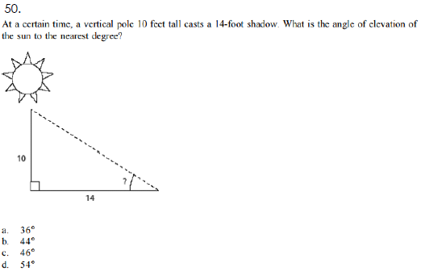  
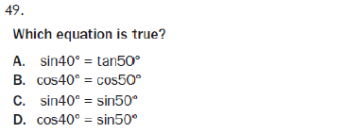

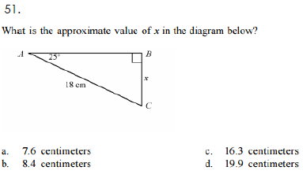

**EOCT Review: Similarity # 52 – 67**

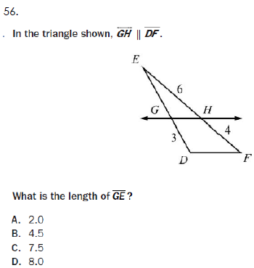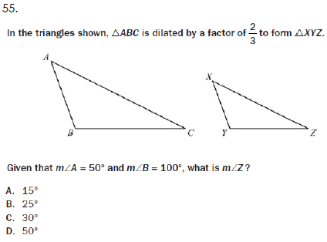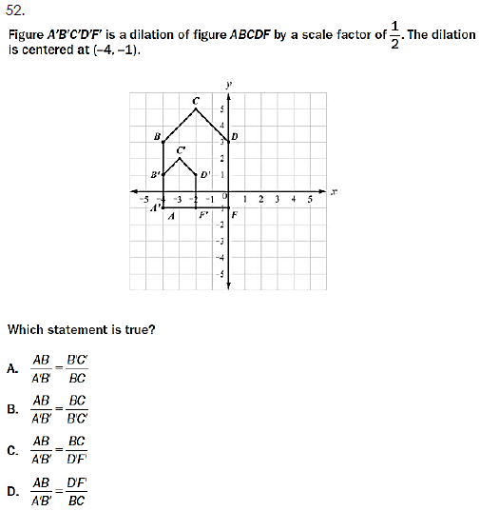

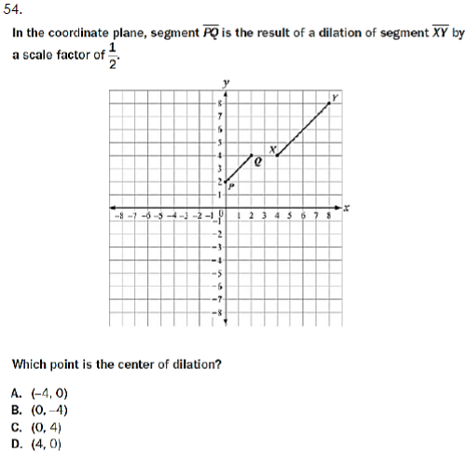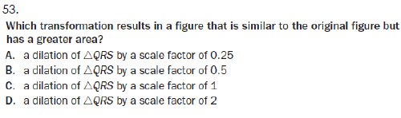

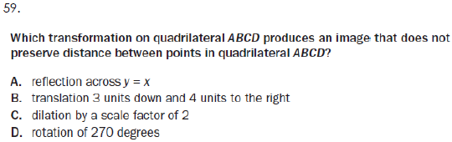

**EOCT Review: Similarity # 52 – 67 (Continued…)**

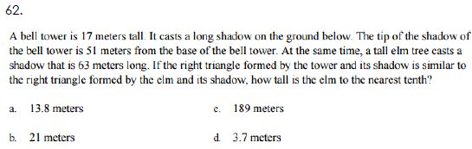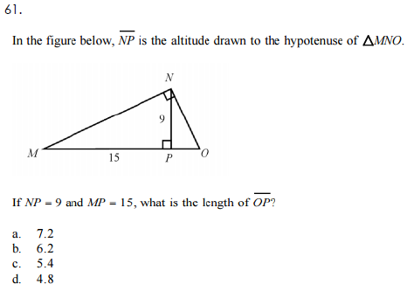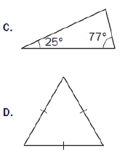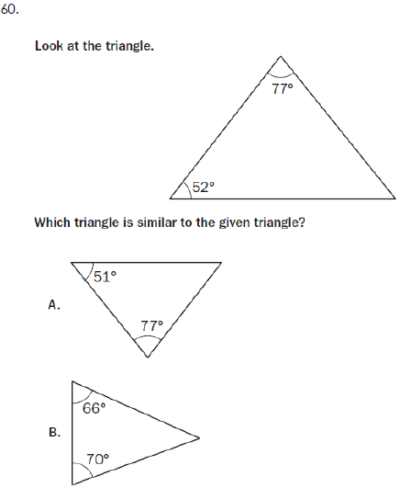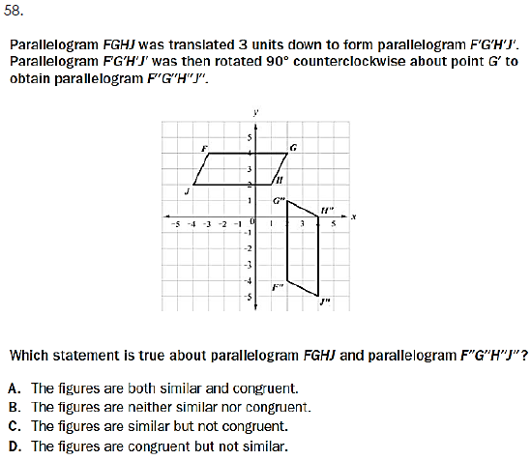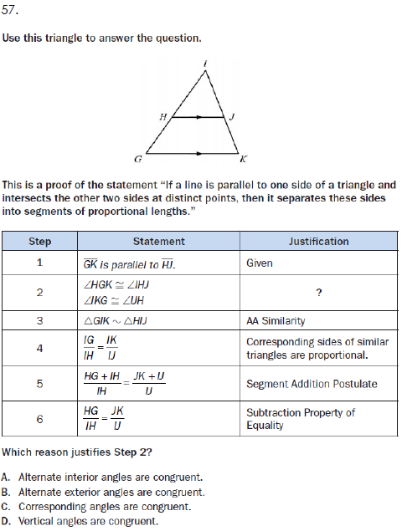

**EOCT Review: Similarity # 52 – 67 (Continued…)**

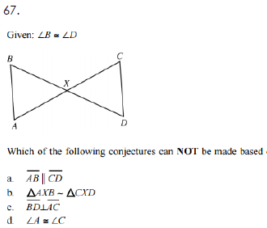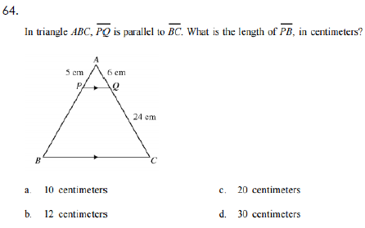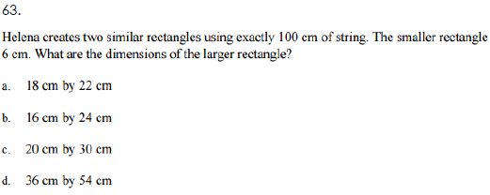



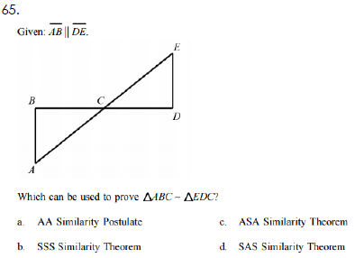

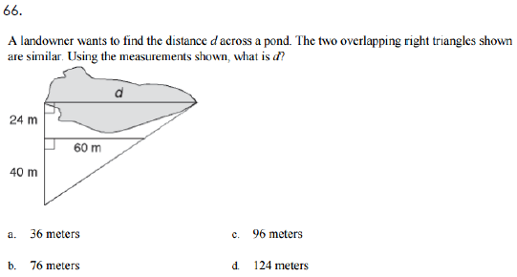

**EOCT Review: Circles # 68 – 78**

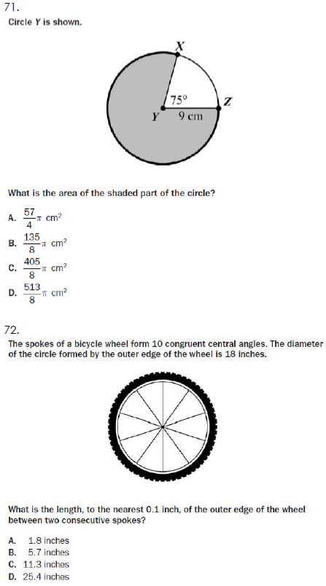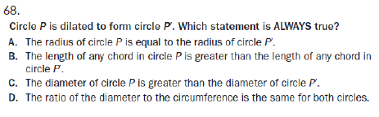

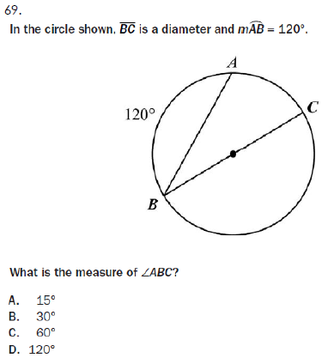

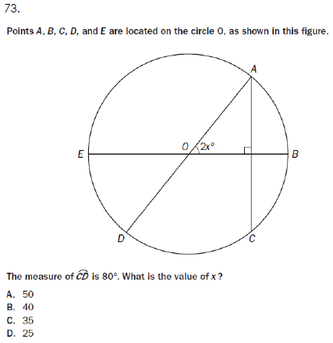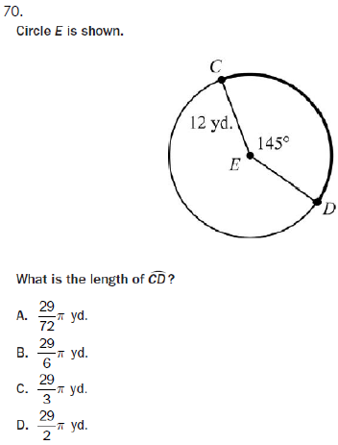

**EOCT Review: Circles # 68 – 78 (Continued…)**

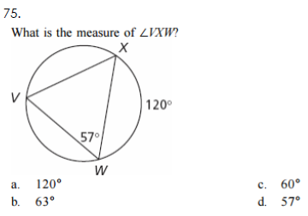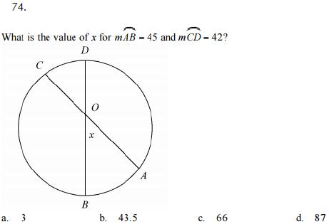

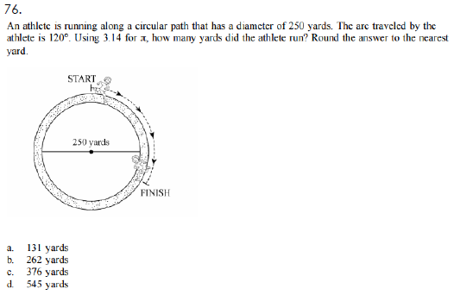

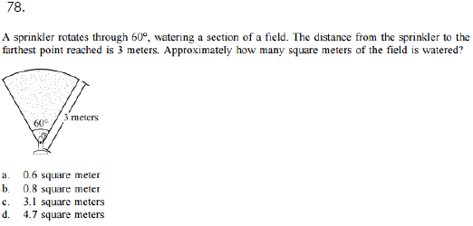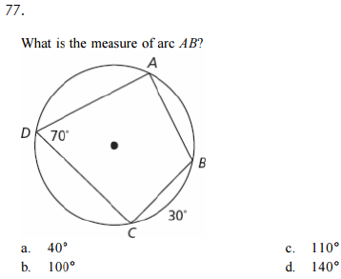

**EOCT Review: Volume # 79 – 82**

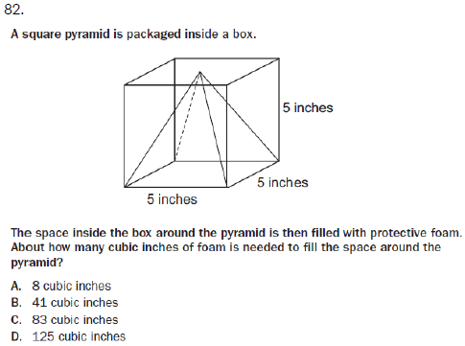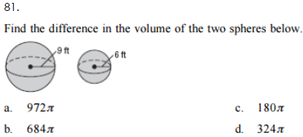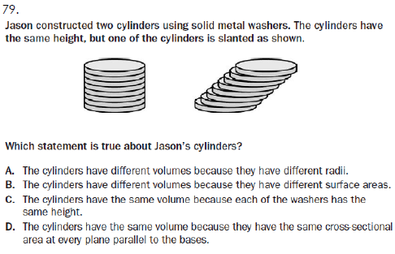

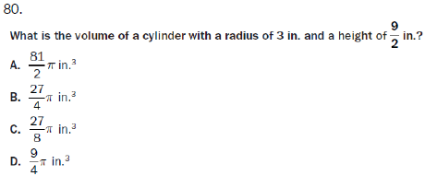

**EOCT Review: Probability # 83 – 91**

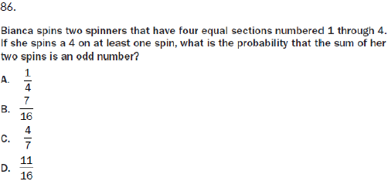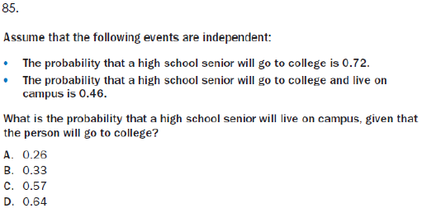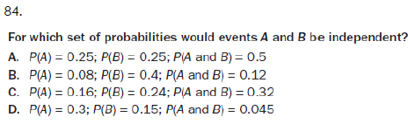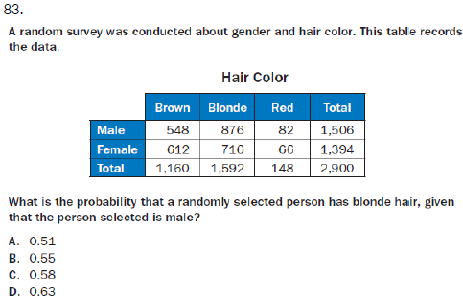

**EOCT Review: Probability # 83 – 91 (Continued…)**

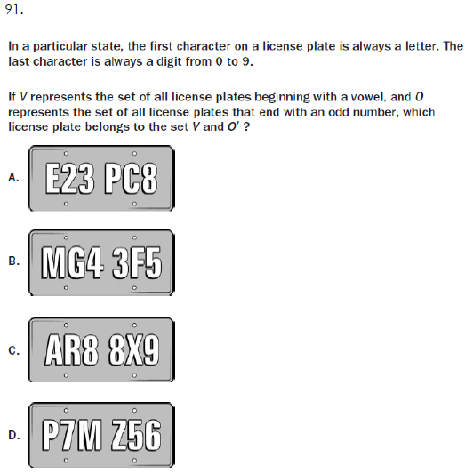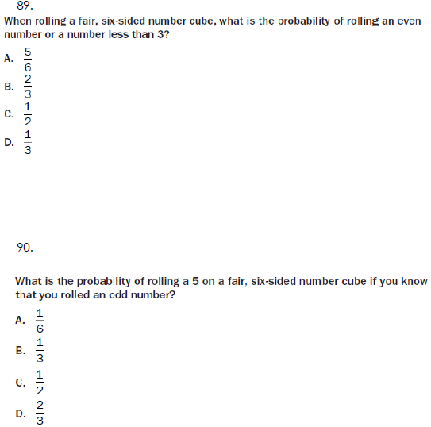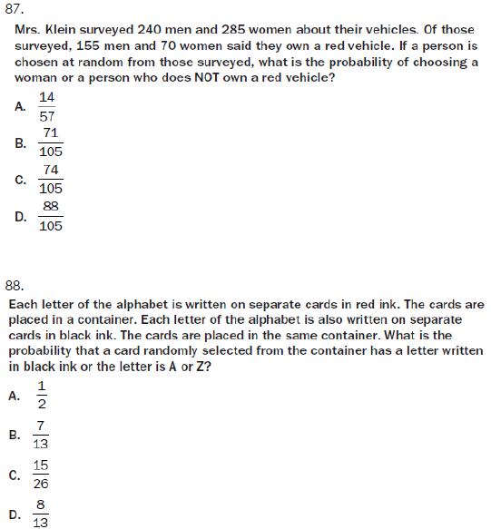

**EOCT Review: Constructions and Modeling Geometry # 92 – 97**

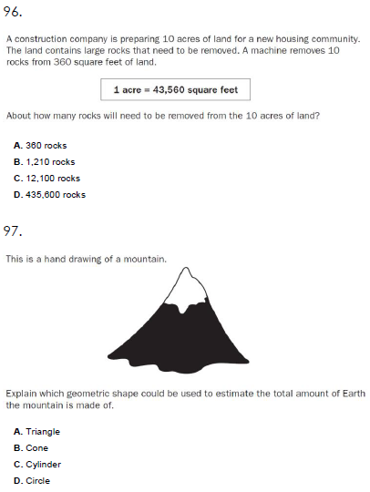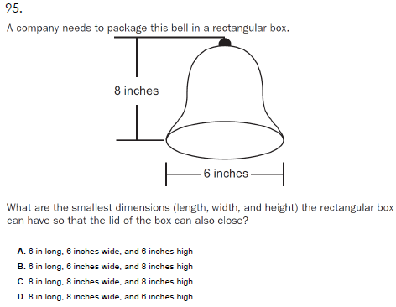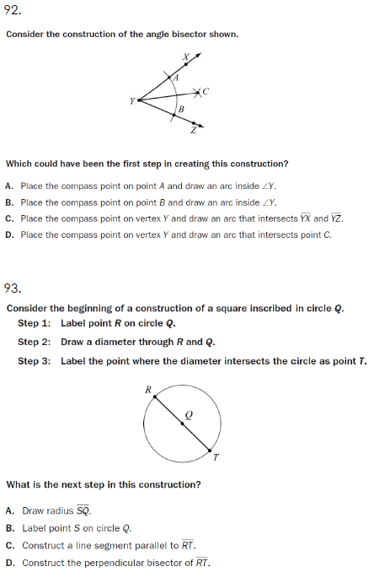

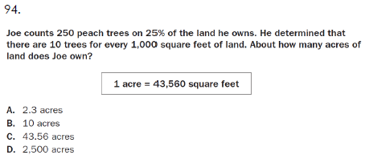

**EOCT Review: Constructed Responses # 98 – 101**

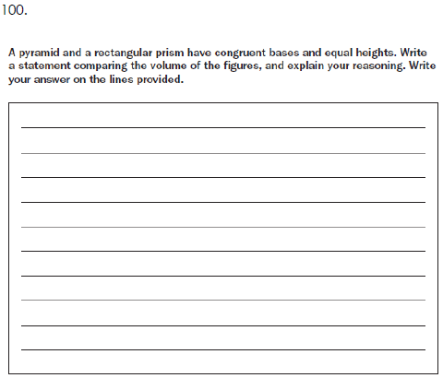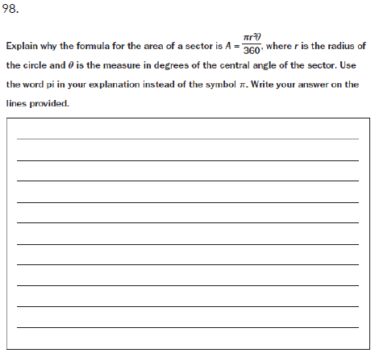

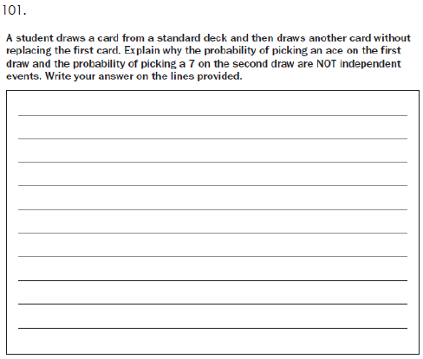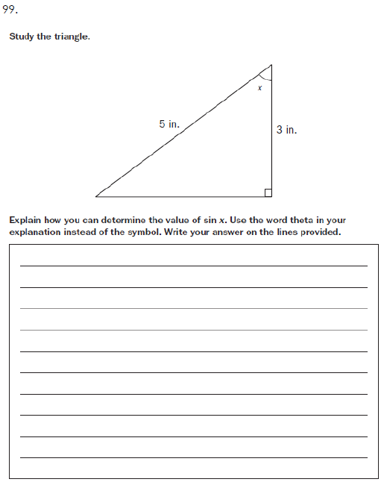

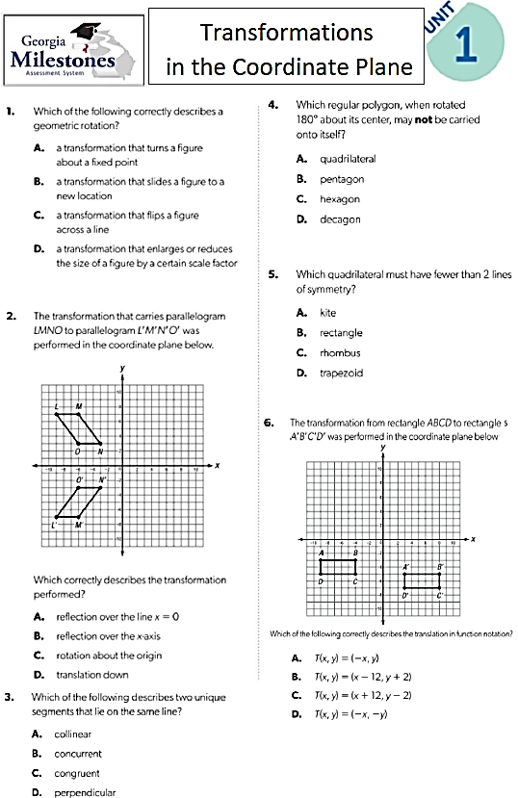

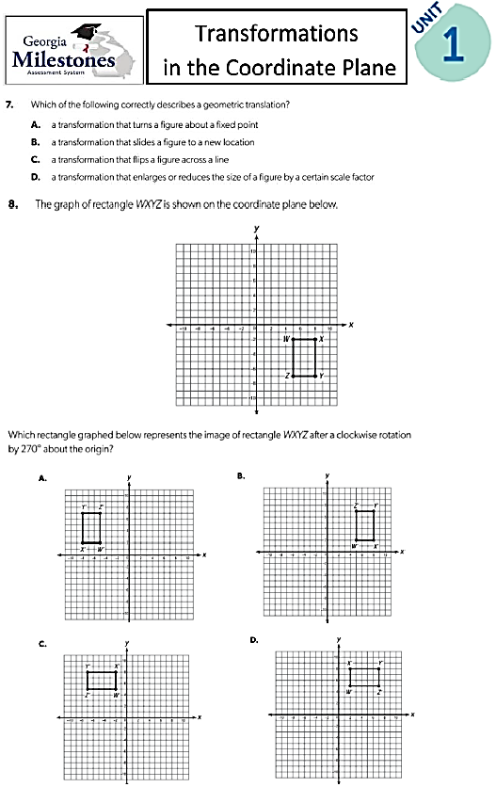

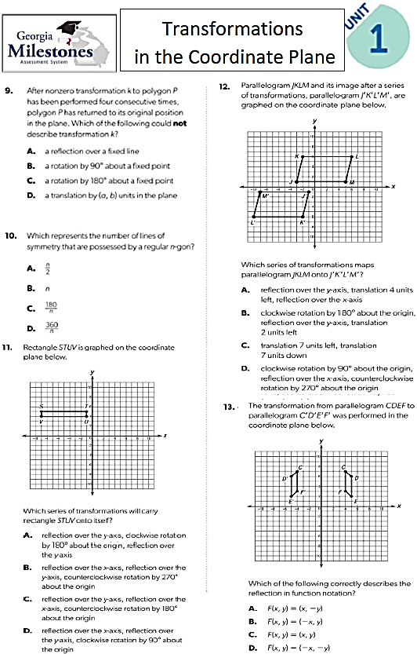

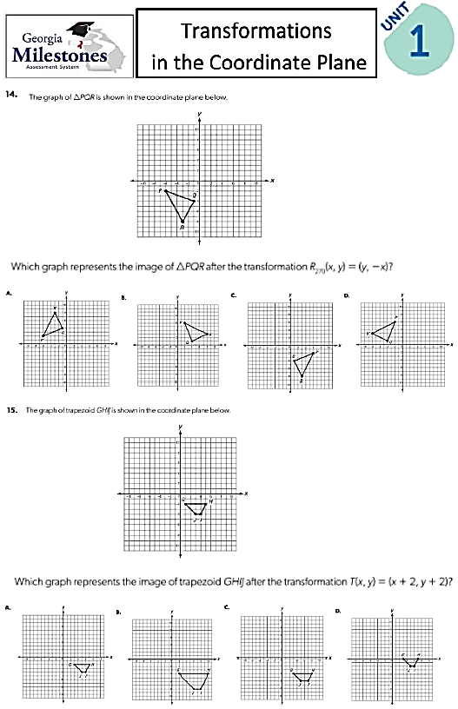

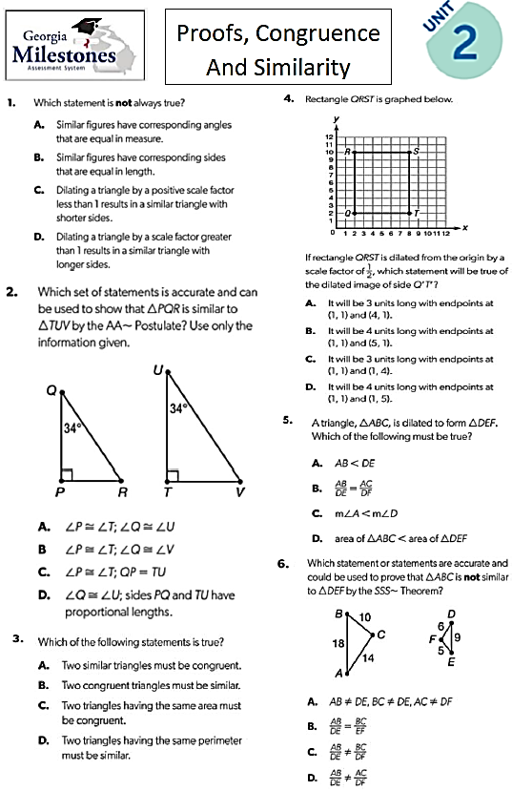

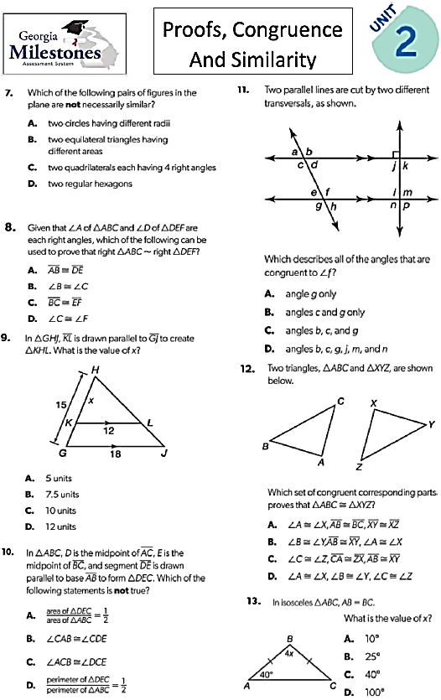

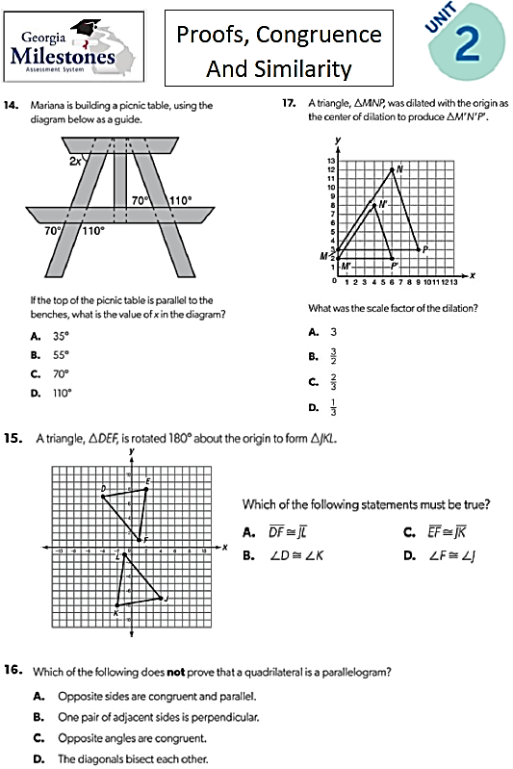

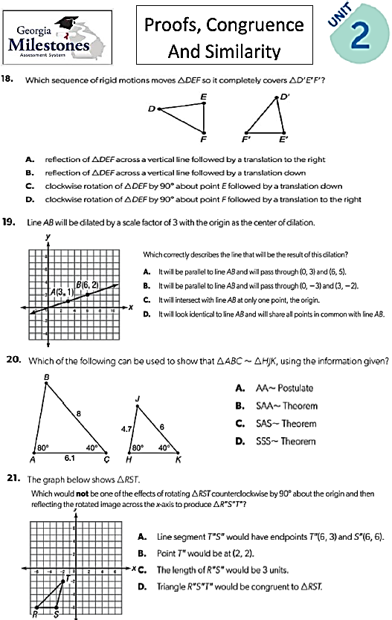

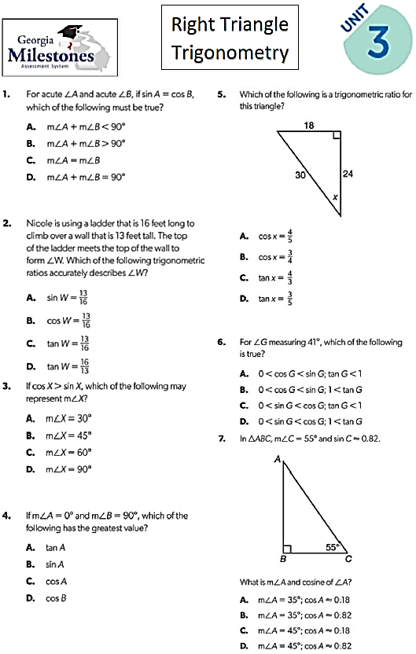

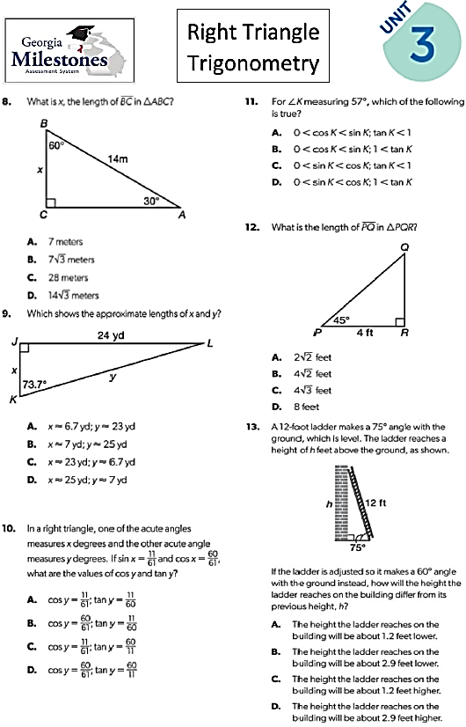

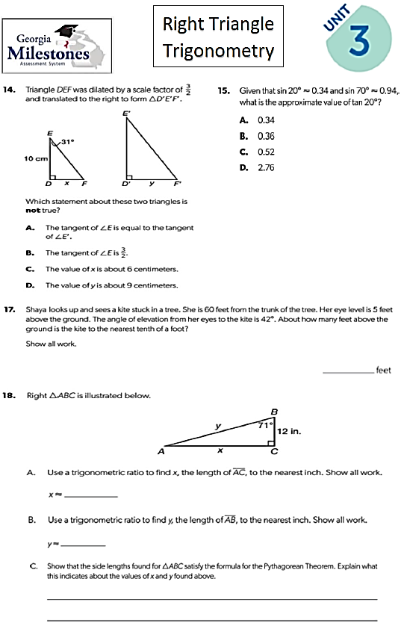

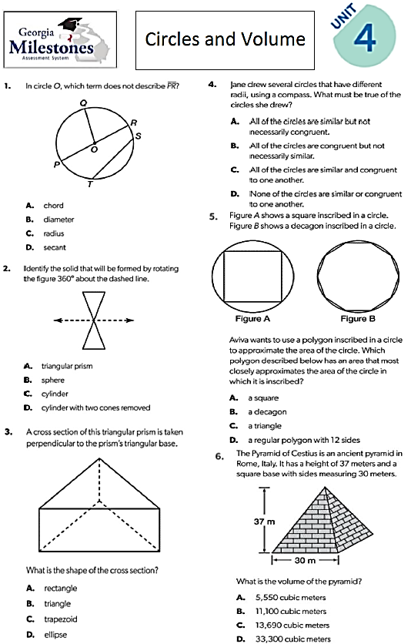

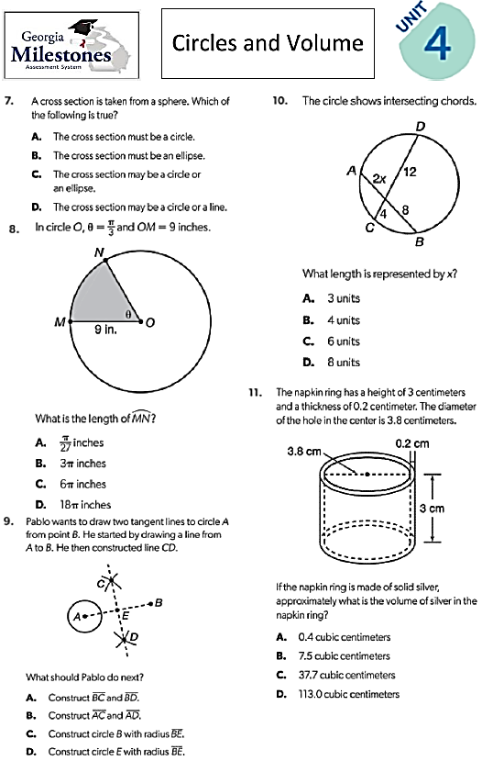

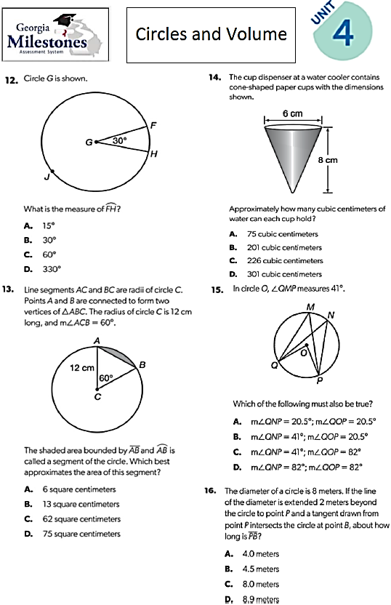

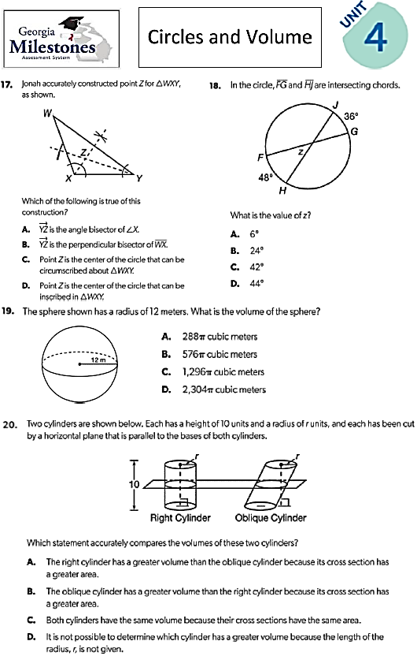

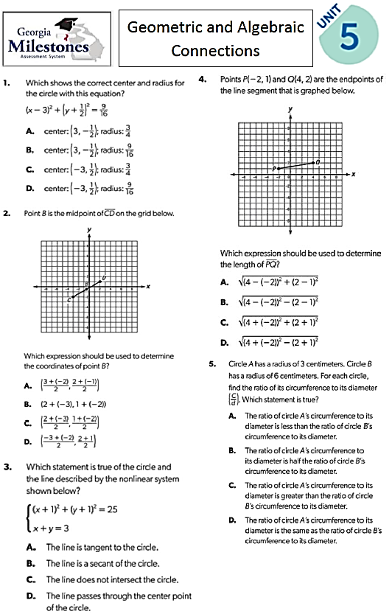

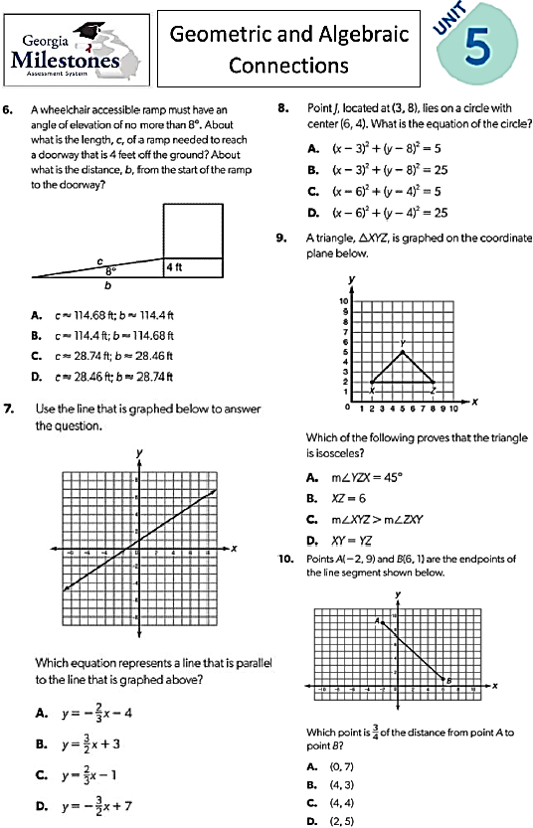

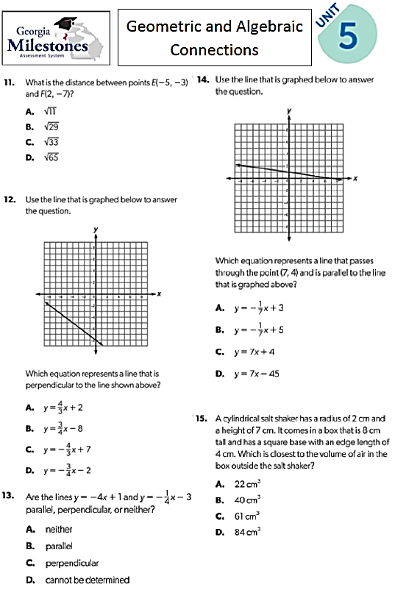

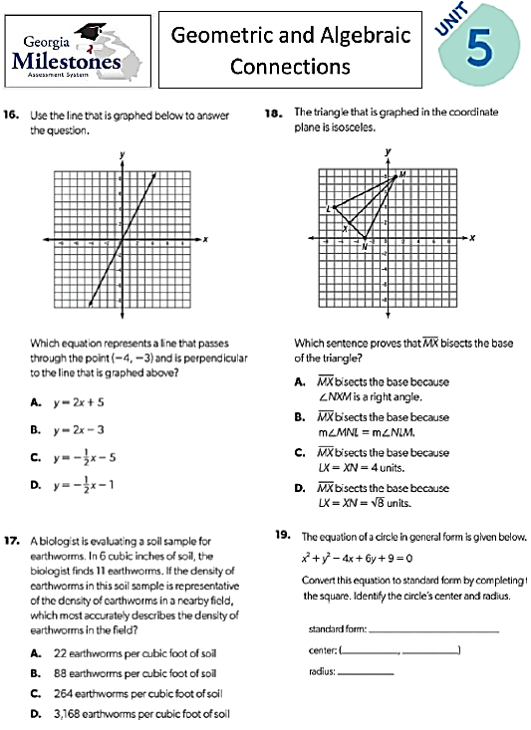

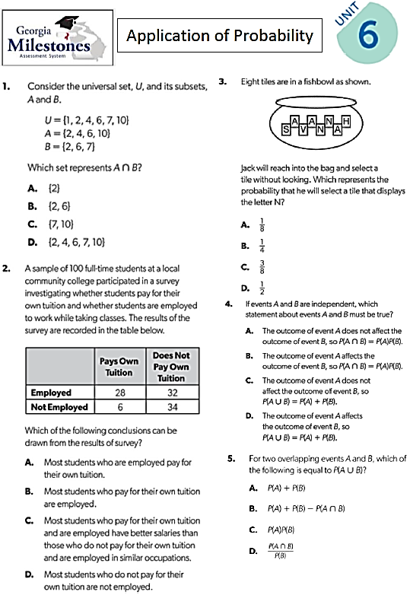

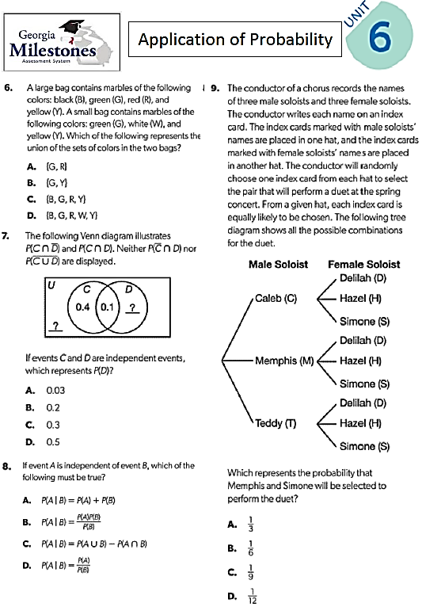

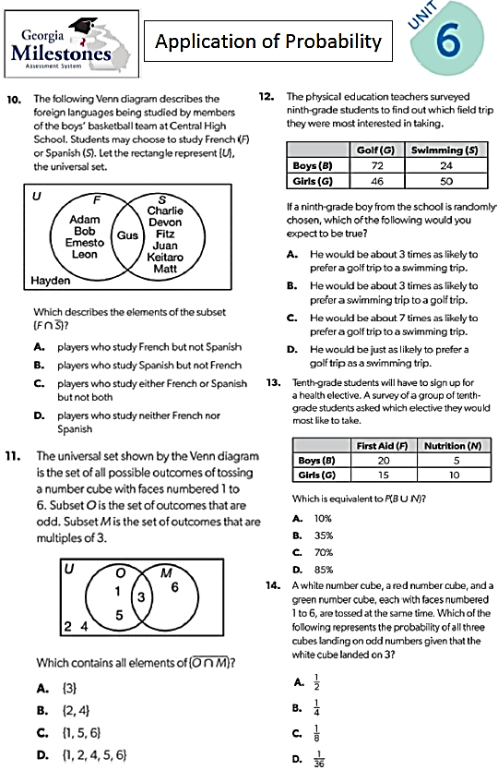

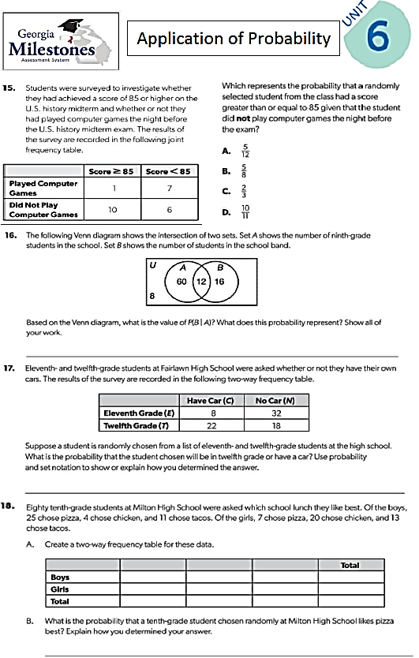

**Unit 1 Answers**

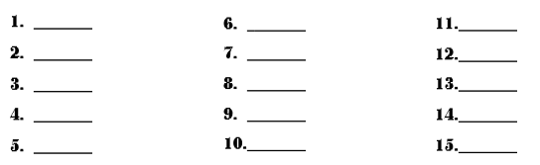

**Unit 2 Answers**

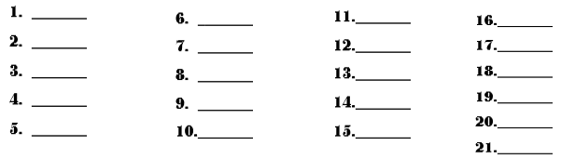

**Unit 3 Answers**



**16. ________________________________________________________________________________**

**________________________________________________________________________________**

**17. (a) _____________________________________ (b)____________________________________**

**(c) _____________________________________________________________________________**

**________________________________________________________________________________**

**________________________________________________________________________________**

**Unit 4 Answers**

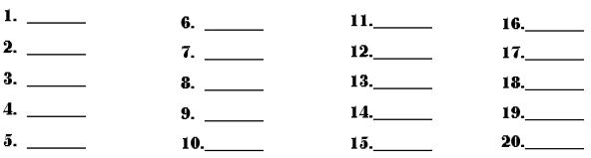

**Unit 5 Answers**

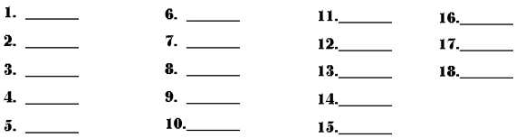

**19. Standard Form ___________________________ Center _____________ Radius ___________**

**Unit 6 Answers**



**16. ______________________________________________________________________________**

**______________________________________________________________________________**

**17. ______________________________________________________________________________**

**______________________________________________________________________________**

1. 